The Internet is a global networks that enables computers of all kinds to directly and transparently communicate and share services
Any two computers, having different software/hardware, can exchange information over the Internet, as long as they obey the technical rules of Internet communication.
The exchange of information occur among connected computers regardless of geographical located.

Internet Timeline/History
Internet started from a prototype research project.
Networking of computers origin at the US Department of Defense Advanced Research Projects Agency (DARPA)
1969s
- ARPA (Advanced Research Project Agency) Sponsored by US Department of Defencedevelop ARPAnet; Internet predecessor.
- Designed to connect Military research centers
- Supports Internetworking
- Overcoming the faults; TCP/IP was developed (set of rules used by a network for communication)
1970s
- US National Science Foundation (NSF) designed a successor to ARPANET, called NSFNET. open for use to all university research groups, libraries and museums.
1980s
- many Internet applications like electronic mail, newsgroups, file transfer facility andremote login were developed.
- telnet
1990s
- New application World Wide Web (WWW) it changed everything about internet
- British scientist Tim Berners Lee
1993s
Mosaic browser; Netscape navigator(Market Dominant)
Internetworking Protocol
TCP/IP is the communication protocol for the Internet
It specifies how data is exchanged over the internet by providing end-to-end communications that identify how it should be broken into packets, addressed, transmitted, routed and received at the destination.
TCP/IP requires little central management, and it is designed to make networks reliable, with the ability to recover automatically from the failure of any device on the network.
The TCP/IP protocol has two parts: TCP and IP
How TCP/IP Works?
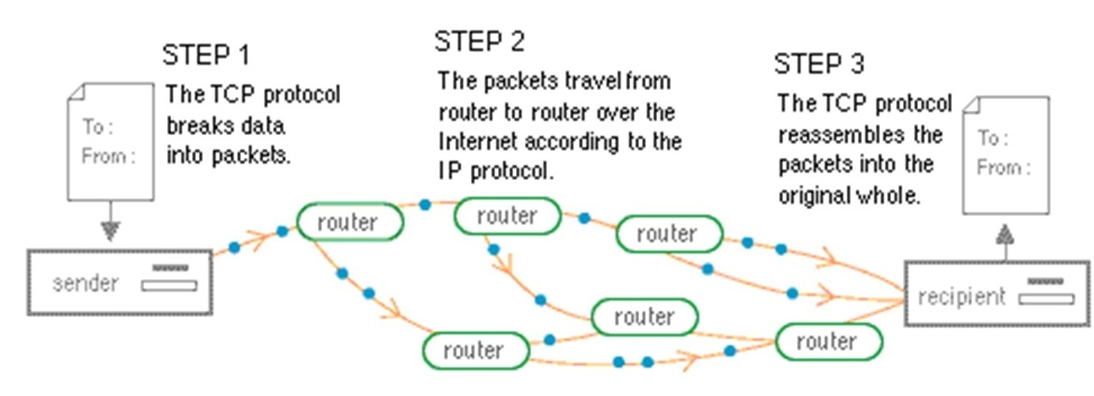
Step 1:
- Each packet contains address, sequencing information, and error control information.The address is used to route the packet to its destination.
- The error control information is used to check that the packet arrived at the destination is the same as that sent from the source
Step 2:
- Internet Protocol (IP) allows different computers to communicate by creating a network ofnetworks.
- IP handles the dispatch of packets over the network.
- It handles the addressing of packets, and ensures that a packet reaches its destination traveling through multiple networks with multiple standards
step 3:
- TCP sequencing information in the packet is used to reassemble the packets in order, at their destination
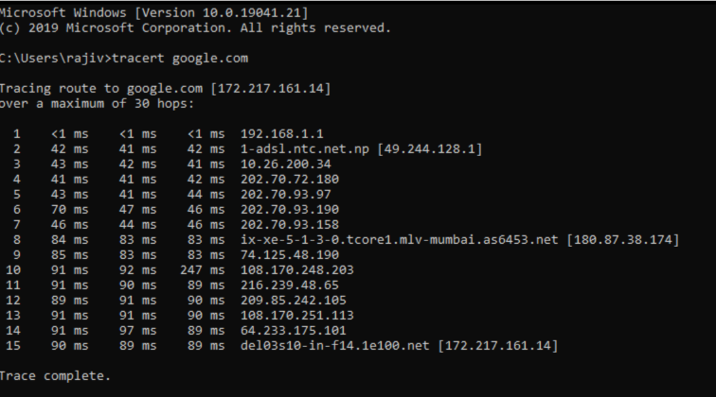
The Internet Architecture/Internet hierarchical
Architecture of Internet is hierarchical in nature
at center: “Backbone” ISPs (e.g., MCI, Sprint, AT&T, Cable and Wireless), national/international coverage
- treat each other as equals
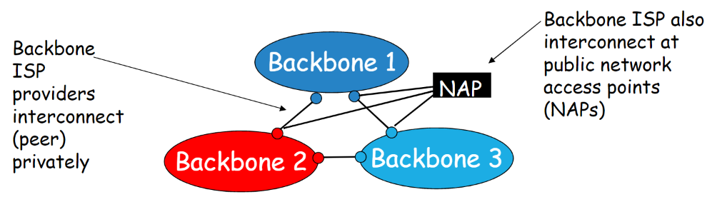
“Regional” ISPs: smaller ISPs
- Connect to one or more Backbone ISPs, possibly other Regional ISPs
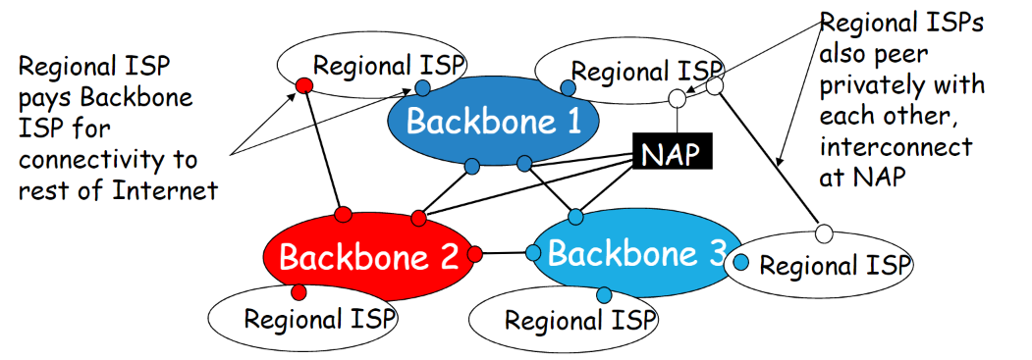
“Tier-3” ISPs and local ISPs
- last hop (“access”) network (closest to end systems)
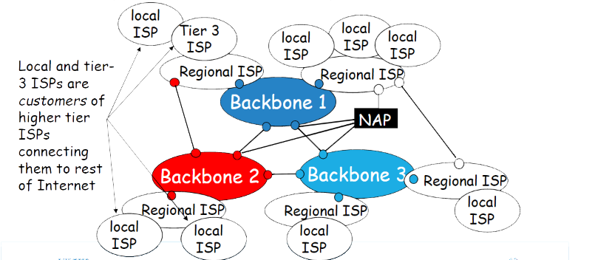
Internet Services
1. Electronic Mail
- Electronic mail (E-mail) is an electronic message transmitted over a network.
- E-mail is a text-based mail consisting of lines of text, and can include attachments (audio messages, pictures and documents).
- Features:
  - Single/Multiple Reception
  - Convenience
  - Faster
  - Record/Reference
  - Attachments of files and documents
  - Unique emai-id enables feature of postal service.(send, reply, forward, store, delete etc)2/25/202014
  - Saves Money & Time
- E-mail Address
  - Consist Three part
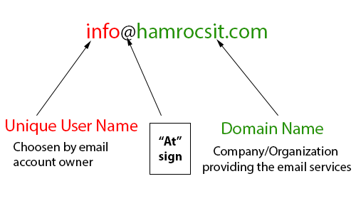
- E-mail Message Format
  - consists of two parts-header and body.
- E-mail Services
  - Application-based e-mail
  - Web-based e-mail
- How E-mail Works
  - client-server model.
  - E-mail clients
  - E-mail server
  - (POP3), (SMTP) & (IMAP).
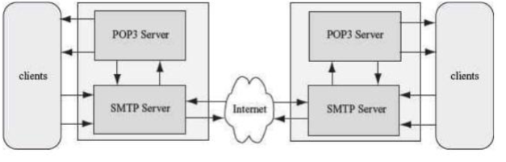
Post Office Protocol 3, Simple Mail Transfer Protocol & Internet Message Access Protocol
SMTP (Simple Mail Transfer Protocol)
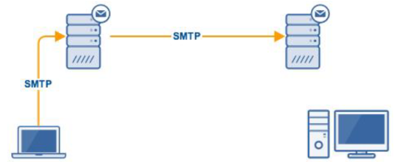
SMTP function is different from the other two.
SMTP mostly used forsending outemail from an email client (e.g. Microsoft Outlook, Thunderbird or Apple Mail) to an email server.
It’s also used forrelayingorforwardingmail messages from one mail server to another.
The ability to relay messages from one server to another is necessary if the sender and recipient have different email service providers.
uses TCP/IP port 25 by default.
POP3 (Post Office Protocol 3)
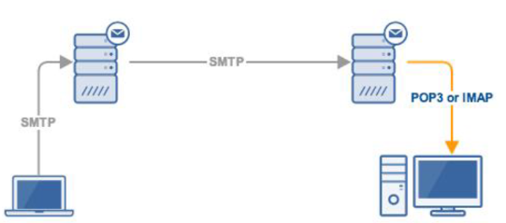
POP is used to retrieve email messages from a mail server to a mail client
POP3 client retrieves email in the following manner:
- Connects to the mail server on port 110 (or 995 for SSL/TLS connections);
- Retrieves email messages;
- Deletes copies of the messages stored on the server; and
- Disconnects from the server
IMAP (Internet Message Access Protocol)
web-based e-mail to access mail on server.
IMAP4 more sophisticated protocol (LATEST)
Retrieves email in the following manner:
- Connects to the mail server on port 143 (or 993 for SSL/TLS connections);
- Retrieves email messages;
- Stays connected until the mail client app is closed and downloads messages on demand.
- Notice that messages aren’t deleted on the server.
Website Processing
- Every website is hosted on a server (physical or virtual) and these servers have a public IP address.
- when a request is made by the client machine for a particular website the browser sees what protocol is being requested
- http uses port 80 for any traffic, while https uses port 443 for its traffic.
- Browser then checks whether thewebsitewas visited before by checking its cache,
- if it was visited before it loads the website from that cache
- if it was not visited before then browser sends it to query the DNS of the local machine which returns with an IP address.
- Once this IP address is received browser then establishes a connection using TCP/IP8.Display the web page
Connecting To Internet
- a TCP/IP enabled computer,
- web browser software,
- Subscription with an ISP,
- Connection with ISP
- a modem or Network Interface Card (NIC)
Internet “Governing” Bodies
- Internet Society (ISOC); Membership Orgn, responsible for development of Standard and Protocolcs
- Internet Architecture Board(IAB); Advisor body of ISOC, development of internet architecture.
- Internet Engineering Task Force (IETF): A body of several thousands or more volunteers network designers, Operators, Vendors and research. Meet three times a year, responsible for evolution of internet,
- Steering Group (IESG); Approves Standards, review standards submitted by IETF.
- Internet Research Task Force (IRTF);
- Internet Assigned Number Authority(IANA);
- Internet Network Information Center (InterNIC);
- World Wide Web Consortium (W3C);
Internet Connections
The ISPs provide Internet connections of different types.
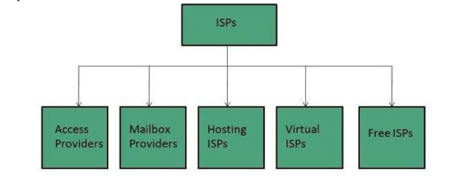
Bandwidth and cost are the two factors
The speed of Internet access depends on the bandwidth. The speed of Internet access increases with the increase in bandwidth.
Speed also depends upon types of connections (Dial-up connection, broadband connection)
Internet Connection Types
1. Dial-up Connection
Dial-up connection uses telephone line to connect PC to the internet. It requires a modem to setup dial-up connection.
communication program that instructs the modem to make a call to specific number provided by an ISP.
Dial-up connection uses either of the following protocols:
- Serial Line Internet Protocol (SLIP)
- Point to Point Protocol (PPP)
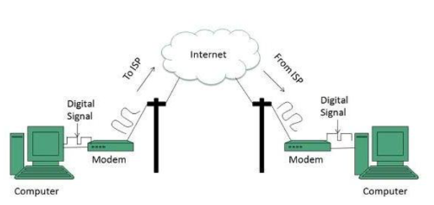
2. ISDN
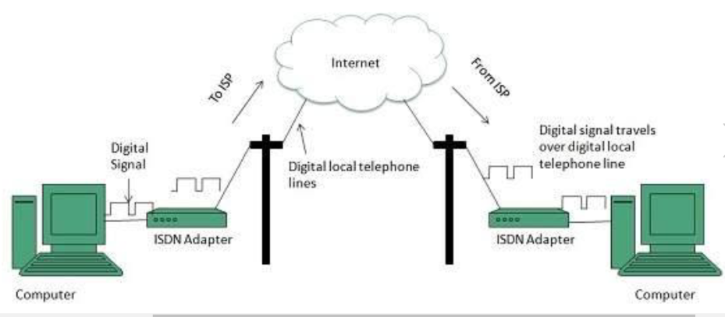
ISDN is Integrated Services Digital Network. It establishes the connection using the phone lines which carry digital signals instead of analog signals.
It can transmit voice, data and control information over an existing single telephone line.
There are two techniques to deliver ISDN services:
- Basic Rate Interface (BRI)
- Primary Rate Interface (PRI)
Key points:
Internet access is faster using ISDN than Dial-up access.
commonly used for business purposes
costlier than Dial-up connection
ISDN services are largely being replaced by high speed broadband connection.
3. DSL (Digital Subscriber Line)
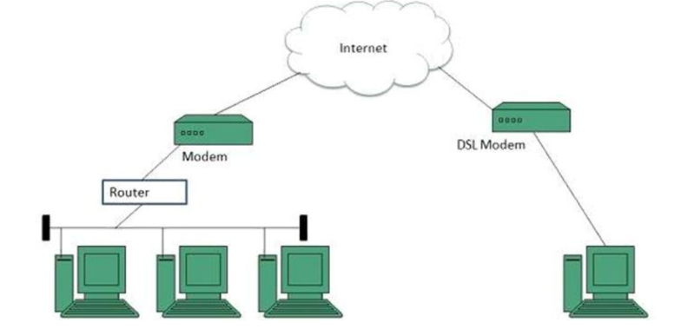It is a form of broadband connection as it provides connection over ordinary telephone lines.
Following are the several versions of DSL technique available today:
- Asymmetric DSL (ADSL
- Symmetric DSL (SDSL)
- High bit-rate DSL (HDSL)
- Rate adaptive DSL (RDSL)
- Very high bit-rate DSL (VDSL)◦ISDN DSL (IDSL)
All of the above mentioned technologies differ in their upload and download speed, bit transfer rate and level of service.
Data transmission speed of DSL ranges from 128 Kbps to 8.448 Mbps.
4. Cable Modem
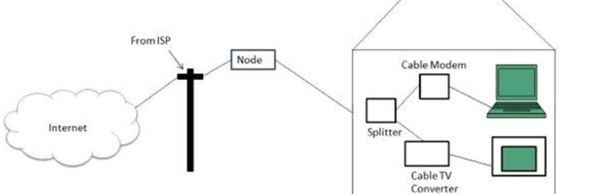
A cable modem is used to access this service, provided by the cable operator.
It uses coaxial cable which is capable of transferring data at much higher speed than common telephone line.
The Cable modem comprises of two connections: one for internet service and other for Cable TV signals.
Since Cable TV internet connections share a set amount of bandwidth with a group of customers, therefore, data transfer rate also depends on number of customers using the internet at the same time.
Internet Address
A computer connected to the Internet must have a unique address in order to communicate across the Internet.
ISP provides unique Internet Protocol (IP) address to every computer connected to the Internet
IP address is a string of numbers consisting of four parts, each part range from 0 to 255
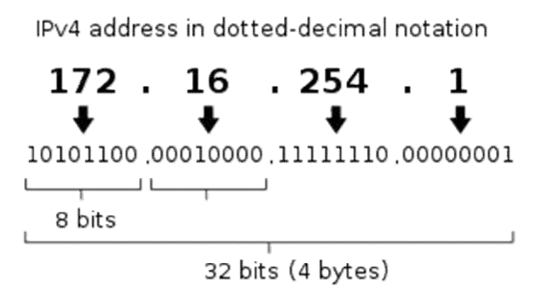
Internet Services
1. FTP (File Transfer Protocol)
FTP is internet tools used to copy files from one host to another.
It gives access to directories of folders and files, allows files to be transferred between different kinds of computers.
Can be used through application platform or web based platform.
FTP encourages indirect use of remote computers to access shared resources.
Can be used among Heterogeneous systems
Can set different access rights to users.
FTP Working:
Typical client-server model
- FTP client: eg: FilezillaClient
- FTP Server: FilezillaServer
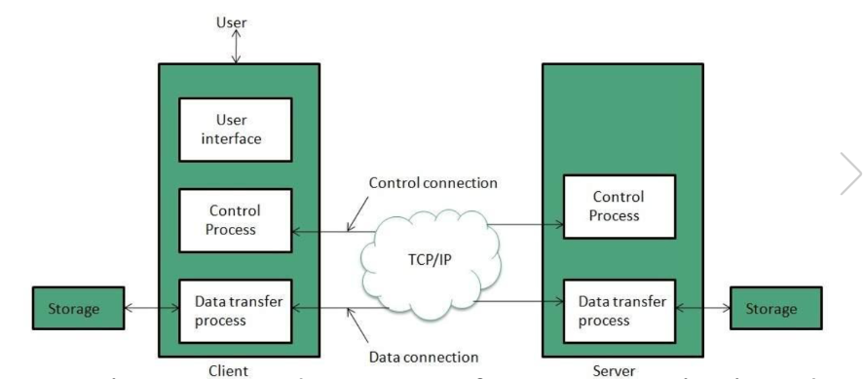
FTP creates two processes such as Control Process and Data Transfer Process at both ends
FTP establishes two different connections: one is for data transfer and other is for control information.
Control connection between control processes while Data Connectionis made between Data Transfer process
FTP usesport 21 for the control connection andPort 20for the data connection.
SN | Parameter | FTP
1 | Operation | Tranfering Files
2 | Authentication | Yes
3 | Protocol | TCP
4 | Ports | 21 –Control, 20 –Data
5 | Control and Data | Separated
6 | Data Transfer | Reliable
2. Telnet (Terminal Network)
Telnet is a protocol that uses the telecommunication network facility that allows a computer to access the contents of another computer
It allows the user to access or edit files, or, issue or execute commands on the host computer
There are a number of Telnet clients having user friendly user interface.
FTP allows transfer of files from the host computer, while Telnet allows access to the computing facility of the host computer but does not allow transfer of files.
The following diagram shows a person is logged in to computer A, and from there, he remote logged into computer B.
3. RC (Instant Relay Communication)
IRC is an APPLICATION LAYER protocol that facilitates the transfer of messages in the form of text.
uses TCP (Transmission Control Protocol)
The chat process works on a client/server networking model.
IRC clients are web based or application based programs. These clients communicate with chat servers to transfer messages to other clients.IRC is mainly designed for GROUP COMMUNICATION.
IRC allows users to communicate in real time by text, instant sending and receiving of messages.
In IRC real identity is undisclosed, doesn’t requires IM authentication.
HydraIRC, mIRC
4. News
News
newsgroups; focused to a specific topic for discussion
People can post/read articles and also respond to articles
Different application/ platforms available.

